Special educational needs (SEN) information report
Chalfont St Giles

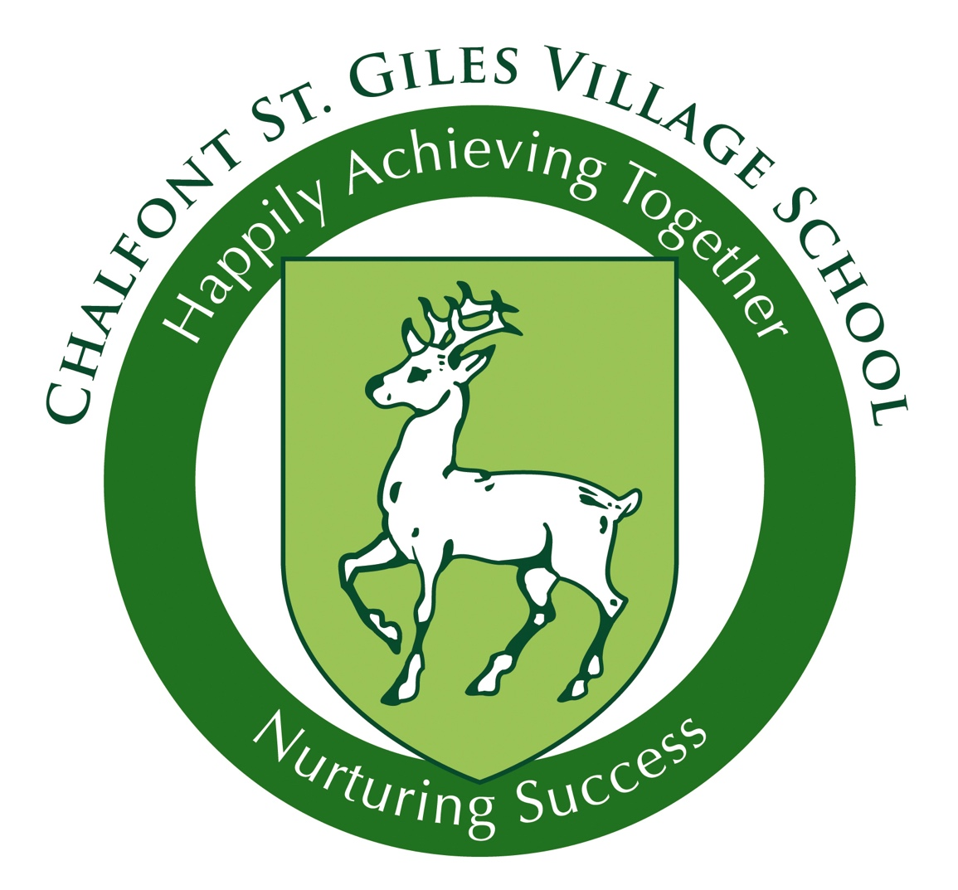

Approved by: | Full Governing Body | Date: School year 2024/25
Last reviewed on: | October 2025
Next review due by: | October 2026

Contents
Contents 3
1. What types of SEN does the school provide for? 4
2. Which staff will support my child, and what training have they had? 4
3. What should I do if I think my child has SEN? 6
4. How will the school know if my child needs SEN support? 6
5. How will the school measure my child’s progress? 7
6. How will I be involved in decisions made about my child’s education? 7
7. How will my child be involved in decisions made about their education? 8
8. How will the school adapt its teaching for my child? 8
9. How will the school evaluate whether the support in place is helping my child? 9
10. How will the school resources be secured for my child? 10
11. How will the school make sure my child is included in activities alongside pupils who don’t have SEN? 10
12. How does the school make sure the admissions process is fair for pupils with SEN or a disability? 10
13. How does the school support pupils with disabilities? 11
14. How will the school support my child’s mental health and emotional and social development? 11
15. What support will be available for my child as they transition between classes or settings or in preparing for adulthood? 11
16. What support is in place for looked-after and previously looked-after children with SEN? 12
17. What should I do if I have a complaint about my child’s SEN support? 12
18. What support is available for me and my family? 13
19. Glossary 13

The aim of this information report is to explain how we implement our SEND policy. In other words, we want to show you how special educational needs support works in our school.
If you want to know more about our arrangements for SEND, read our SEND policy.
You can find it on our website www.csgvillageschool.org/send/

Note: If there are any terms we’ve used in this information report that you’re unsure of, you can look them up in the Glossary at the end of the report.

1. What types of SEN does the school provide for?
Our school provides for pupils with the following needs:

Area of need | Condition
Communication and interaction | Autism spectrum disorder (ASD)
Communication and interaction | Speech and language difficulties
Cognition and learning | Specific learning difficulties, including dyslexia, dyspraxia, dyscalculia
Cognition and learning | Moderate Learning Difficulties
Social, emotional and mental health | Attention deficit hyperactivity disorder (ADHD)
Social, emotional and mental health | Emotional Based School Avoidance
Sensory and/or physical | Hearing impairments
Sensory and/or physical | Visual impairment
Sensory and/or physical | Multi-sensory impairment
Sensory and/or physical | Physical impairment

2. Which staff will support my child, and what training have they had?

Our special educational needs co-ordinator, or SENCO 
Our SENCO is Sarah Pierpoint.
Miss Pierpoint joined Chalfont St Giles in 2022, having previously worked in special schools. She is a qualified Teacher, has Qualified Teacher of the Visually Impaired status and has achieved the National Award in Special Educational Needs Co-Ordination.
Miss Pierpoint’s working days are Monday-Thursday, and you can contact her through the school office, or via the SENCO contact form on the school website.
Class teachers
Class teachers hold the overall responsibility for pupils with SEN, and are key in identifying pupils who require additional support above the ordinarily available provision. All of our teachers receive in-house SEN training, and are supported by the SENCO to meet the needs of pupils who have SEN.
Learning Support Assistants and Special Support Assistants
Each class has access to an LSA who is trained to run small groups or take children for interventions. If a child has an EHCP or is on track to be assessed for an EHCP, they may work with a Special Support Assistant. Although we endeavour to keep staffing consistent, there is no guarantee that this will always be the case. We do encourage pupils to build relationships with a variety of staff and may sometimes have to make alterations to staffing.
Emotional Literacy Support Assistant
At Chalfont St Giles, we have Mrs Rock, a trained ELSA, who works with children for emotional based difficulties. Sessions with Mrs Rock are arranged via discussions as a team.

Training
In the academic year 24-25, Teachers, LSA’s and SSA’s had access to training in:
- Lego Therapy
- Precision Monitoring
- Using Symbols/Visuals
- Attention Autism/Bucket Time
- Tree of Life
- Autism awareness
- ADHD awareness
- Dyslexia
- Circles of Control and emotional understanding
- BSL
- Sensory Circuits

In previous years, staff have also received training in:
- Autism in the early Years
- Self regulation
- Occupational Therapy techniques
- ADHD
- Makaton
- Mental Health
- PDA
- Selective Mutism

Plans for 2025-2026 include access to training in Autism, Makaton, Bucket Time, Sensory Circuits, Dyslexia, Occupation Therapy.

External agencies and experts
Sometimes we need extra help to offer our pupils the support they need. Whenever necessary we will work with external support services to meet the needs of our pupils with SEN and to support their families. These include:
- NHS Speech and language therapists (SLT)
- County Employed Educational psychologists (EP)
- NHS Occupational therapists (OT)
- GPs or paediatricians
- School nurses
- Child and adolescent mental health services (CAMHS)
- Social services and other local authority (LA)-provided support services
- Voluntary sector organisations
- Play Therapist
- Pupil Referral Unit

3. What should I do if I think my child has SEN?

If you think your child might have SEN, the first person you should tell is your child’s teacher.  They will pass the message on to our SENCO, Sarah Pierpoint, who will be in touch to discuss your concerns.  You can also contact the SENCO directly via the school office. | We will meet with you to discuss your concerns and try to get a better understanding of what your child’s strengths and difficulties are.  Together we will decide what outcomes to seek for your child and agree on next steps.  We will make a note of what’s been discussed and add this to your child’s record. | If we decide that your child needs SEN support, we will formally add them to the SEND register.

4. How will the school know if my child needs SEN support?

Chalfont St Giles Village School provides a high quality and challenging education for all its pupils and believes that every pupil is entitled to reach the highest level of personal achievement. We provide inclusive, broad and balanced educational opportunities in order to meet the differing needs of the pupils attending. We are committed to removing barriers to learning and meeting the needs of individual learning.
All our class teachers are aware of SEN and are on the lookout for any pupils who aren’t making the expected level of progress in their schoolwork or socially. This would also be highlighted through our termly Pupil Progress meetings and data collection.
If, despite the high-quality teaching for all, the teacher notices that a pupil is falling behind, extra intervention sessions will be planned for. If the pupil is still struggling to make the expected progress, the teacher will talk to the SENCO, and will contact you to discuss the possibility that your child has SEN.
The SENCO will ask for your opinion and speak to your child, where appropriate, to get their input as well. They may also, where appropriate, ask for the opinion of external experts such as a speech and language therapist, specialist teachers, an educational psychologist, or a paediatrician.
Based on all of this information, the SENCO will decide whether your child needs SEN support.
If your child does need SEN support, their name will be added to the school’s SEND register, and the SENCO will work with you to create a SEN support plan for them.

5. How will the school measure my child’s progress?
We will follow the ‘graduated approach’ to meeting your child’s SEN needs.
The graduated approach is a 4-part cycle of assess, plan, do, review.
Review
We will assess how well the support we put in place helped the child to meet the outcomes we set. We will use our improved understanding of
your child’s needs to improve the support we offer.
Assess
If your child is not making the expected level of progress, we will make an assessment to find out what strengths and difficulties your child has. We will ask for input from you and your child, as well as getting help from external professionals where necessary.

Plan
In discussion with you and your child, we will decide what outcomes we are hoping to achieve. We will make a plan of the support we will offer your child to help them meet those outcomes. We will make a record of this and share it with you and all relevant school staff.
Do
We will put our plan into practice.
The class teacher, with the support of the SENCO, will be responsible for working with your child on a daily basis, and making sure the support we put in place is having the impact we intended.

As a part of the planning stage of the graduated approach, we will set outcomes that we want to see your child achieve.
We will track your child’s progress towards the outcomes we set over time and improve our offer as we learn what your child responds to best.
This process will be continual. If the review shows a pupil has made progress, they may no longer need the additional provision made through SEN support. For others, the cycle will continue and the school's targets, strategies and provisions will be revisited and refined.

6. How will I be involved in decisions made about my child’s education?
The SENCO, Miss Pierpoint will invite you to meet them along with your class teacher 3 times a year in October, February and May to:
- Set clear outcomes for your child’s progress
- Review progress towards those outcomes
- Discuss the support we will put in place to help your child make that progress
- Identify what we will do, what we will ask you to do, and what we will ask your child to do

We know that you’re the expert when it comes to your child’s needs and aspirations, so we want to make sure you have a full understanding of how we’re trying to meet your child’s needs, so that you can provide insight into what you think would work best for your child.
We also want to hear from you as much as possible so that we can build a better picture of how the SEN support we are providing is impacting your child outside of school.
After any discussion we will make a record of any outcomes, actions and support that have been agreed. This record will be shared with all relevant staff, and you will be given a copy.
If you have concerns that arise between these meetings, or require a longer meeting, please contact your child’s class teacher or Miss Pierpoint.

7. How will my child be involved in decisions made about their education?
The level of involvement will depend on your child’s age and level of competence. We recognise that no 2 children are the same, so we will decide on a case-by-case basis, with your input.
We may seek your child’s views by asking them to:
- Suggest a target that they would like to achieve
- Prepare a presentation, written statement, video, drawing, etc.
- Discuss their views with a member of staff who can act as a representative during the meeting
- Complete a survey

8. How will the school adapt its teaching for my child?
Your child’s teacher is responsible for the progress and development of all the pupils in their class.
High-quality teaching is our first step in responding to your child’s needs. We will make sure that your child has access to a broad and balanced curriculum in every year they are at our school.
We will differentiate (or adapt) how we teach to suit the way the pupil works best. There is no '1 size fits all’ approach to adapting the curriculum, we work on a case-by case basis to make sure the adaptations we make are meaningful to your child.
These adaptations include:
- Ordinarily Available Provision (OAP) https://schoolsweb.buckscc.gov.uk/send-and-inclusion/sendsupport/ordinarily-available-provision/
- Differentiating our teaching, for example, giving longer processing times, pre-teaching of key vocabulary, reading instructions aloud, etc.
- Adapting our resources and staffing
- Using recommended aids, such as laptops, coloured overlays, visual timetables, larger font, etc.
- LSA’s supporting pupils in small groups under the direction of the teacher

We may also provide the following interventions:
Area of need | Condition | How we support these pupils
Communication and interaction | Autism spectrum disorder (ASD) | Visual timetables  Social stories  Now and next boards  Task boards
Communication and interaction | Speech and language difficulties | Speech and language therapy (provided externally)  Vocabulary pre-teaching
Cognition and learning | Specific learning difficulties, including dyslexia, dyspraxia and dyscalculia | Writing slope  Specialist equipment (recommended by external specialists)  Adapted print outs  Access to specific computer programmes such as Nessy
Cognition and learning | Moderate learning difficulties | Visual timetables  Taskboards
Cognition and learning | Severe learning difficulties | Input from specialist teachers for individual learning styles.
Social, emotional and mental health | ADHD, ADD | Movement break request cards  Sensory Circuits
Social, emotional and mental health | Adverse childhood experiences and/or mental health issues | Access to ELSA or Play Therapy
Sensory and/or physical | Hearing impairment | Review of classroom seating arrangements  Use of radio mike if supplied by specialist teachers
Sensory and/or physical | Visual impairment | Review of classroom seating arrangements  Use visual overlays  Change in print size
Sensory and/or physical | Physical impairment

These interventions are part of our contribution to Buckinghamshire County Council’s local offer.

9. How will the school evaluate whether the support in place is helping my child?
We will evaluate the effectiveness of provision for your child by:
- Reviewing their progress towards their goals each term
- Reviewing the impact of interventions each term
- Monitoring by the SENCO
- Using provision maps to measure progress
- Holding an annual review (if they have an education, health and care (EHC) plan)

10. How will the school resources be secured for my child?
It may be that your child’s needs mean we need to secure:
- Extra equipment or facilities
- More teaching assistant hours
- Further training for our staff
- External specialist expertise
If that’s the case, we will consult with external agencies to get recommendations on what will best help your child access their learning.

11. How will the school make sure my child is included in activities alongside pupils who don’t have SEN?

All of our extra-curricular activities and school visits are available to all our pupils, including those before and after-school clubs.
All pupils are encouraged to go on our school trips, including our residential trips.
All pupils are encouraged to take part in all school events both in school, sports day, school plays etc and those in our local community, for example at our local church
No pupil is deliberately excluded from taking part in these activities because of their SEN or disability and we will work with the pupil and family to make reasonable adjustments where possible to encourage inclusion.

12. How does the school make sure the admissions process is fair for pupils with SEN or a disability?
Chalfont St Giles Village Schools make provision for every kind of frequently occurring special educational need with or without an Education, Health and Care Plan (EHCP). For instance dyslexia, dyspraxia, speech and language needs, autism, learning difficulties and social, mental health and emotional difficulties. Our staff have a wealth of experience when dealing with many different types of special educational need and will always give their best endeavors to meet the needs of all pupils.
Decisions on the admission of pupils with an Education, Health and Care Plan are made by the Local Authority. The admission arrangements for pupils without an Education, Health and Care Plan do not discriminate against or disadvantage disabled children or those with special educational needs.
All children whose Education, Health and Care (EHC) plan names a school will be admitted before any other places are allocated. This process is done in line with the consultation process and Buckinghamshire County Council.
In the event that the school receives more applications than the number of places it has available, places will be given to those children who meet the criteria set out below, in order until all places are filled.
More information can be found at https://www.buckinghamshire.gov.uk/schools-and-learning/schools-index/school-admissions/school-admissions-guides-policies-and-statistics/guide-to-starting-school-or-moving-up-to-junior-school/admission-rules/#:~:text=Common%20admission%20rules%20may%20include,living%20closest%20to%20the%20school

13. How does the school support pupils with disabilities?
Chalfont St Giles Villages schools are committed to supporting pupils with disabilities through a comprehensive approach that includes an inclusive curriculum, fully accessible environment that meets their education, physical, sensory, social, emotional and cultural needs. Our holistic approach ensures that every student, regardless of their abilities, receives a quality education in a supportive and inclusive setting.
Please also see our Accessibility Policy

14. How will the school support my child’s mental health, and emotional and social development?
We provide support for pupils to progress in their emotional and social development in the following ways:
- Pupils with SEN are encouraged to be part of the school council and other school responsibilities
- We have an ELSA who works closely with all pupils who need extra emotional support, and is also available for ad-hoc drop in sessions
- We have a ‘zero tolerance’ approach to bullying. Please see our Anti-Bullying policy

15. What support will be available for my child as they transition between classes or settings, or in preparing for adulthood?
Between years
To help pupils with SEN be prepared for a new school year we:
- Ask both the current teacher and the next year’s teacher to meet together to discuss the needs of the pupil
- Have transition day where new teachers meet and work with new pupils
- When moving from our Infant school to our junior school we provide a transition week for pupils to spend time in the junior school
Between schools
When your child is moving on from our school, we will ask you and your child what information you want us to share with the new setting.
The SENCO of the secondary school will come into our school for a meeting with our SENCO. They will discuss the needs of all the children who are receiving SEN support.
Pupils will be prepared for the transition according to their individual needs, this could include
- Enhanced transition with the secondary
- Social skills groups preparing for secondary situations
- Extra meetings between key staff

16. What support is in place for looked-after and previously looked-after children with SEN?
Alastair Haywood, our named person for Looked after children will work with Miss Pierpoint, our SENCO, to make sure that all teachers understand how a looked-after or previously looked-after pupil’s circumstances and their SEN might interact, and what the implications are for teaching and learning.
Children who are looked-after or previously looked-after will be supported much in the same way as any other child who has SEN. However, looked-after pupils will also have a personal education plan (PEP). We will make sure that the PEP and any SEN support plans or EHC plans are consistent and complement one another.
We also work closely with the Virtual School to ensure the childs needs are met. More information can be found at https://familyinfo.buckinghamshire.gov.uk/education-and-learning/the-virtual-school/

17. What should I do if I have a complaint about my child’s SEN support?
Complaints about SEN provision in our school should be made to the Class Teacher in the first instance, if this is not resolved contact can be made directly with the SENCO, Miss Pierpoint.
If you are not satisfied with the school’s response, you can escalate the complaint to the Head Teacher, Alastair Haywood. In some circumstances, this right also applies to the pupil themselves.
To see a full explanation of suitable avenues for complaint, see pages 246 and 247 of the SEND Code of Practice.
If you feel that our school has discriminated against your child because of their SEN, you have the right to make a discrimination claim to the first-tier SEND tribunal. To find out how to make such a claim, you should visit: https://www.gov.uk/complain-about-school/disability-discrimination
You can make a claim about alleged discrimination regarding:
- Admission
- Exclusion
- Provision of education and associated services
- Making reasonable adjustments, including the provision of auxiliary aids and services
Before going to a SEND tribunal, you can go through processes called disagreement resolution or mediation, where you try to resolve your disagreement before it reaches the tribunal.
Global Mediation on 0800 064 4488. This service is free of charge.

18. What support is available for me and my family?
If you have questions about SEN, or are struggling to cope, please get in touch to let us know. We want to support you, your child and your family.
To see what support is available to you locally, have a look at Buckinghamshire County Council’s Local offer.publishes information about the local offer on their website:
https://familyinfo.buckinghamshire.gov.uk/send/
Our local special educational needs and disabilities information, advice and support (SENDIAS) services are:
Independent support is available for parents/carers undergoing the Education, Health and Care (EHC) Assessment and Planning Process, both with new EHC Plans or Learning Disability Assessments via SEND Information, Advice and Support Service (SENDIAS). The service is provided by Adviza, a charity whose purpose and passion is to support young people and others making important decisions in their lives, especially those who are vulnerable. SENDIAS Contact details; 01296 383 754 E-mail: sendias@buckinghamshire.gov.uk Website:https://www.buckinghamshire.gov.uk/schools-and-learning/bucks-sendias-service/
National charities that offer information and support to families of children with SEN are:
- IPSEA
- SEND family support
- NSPCC
- Family Action
- Special Needs Jungle

19. Glossary
- Access arrangements – special arrangements to allow pupils with SEN to access assessments or exams
- Annual review – an annual meeting to review the provision in a pupil’s EHC plan
- Area of need – the 4 areas of need describe different types of needs a pupil with SEN can have. The 4 areas are communication and interaction; cognition and learning; physical and/or sensory; and social, emotional and mental health needs
- CAMHS – child and adolescent mental health services
- Differentiation – when teachers adapt how they teach in response to a pupil’s needs
- EHC needs assessment – the needs assessment is the first step on the way to securing an EHC plan. The local authority will do an assessment to decide whether a child needs an EHC plan
- EHC plan – an education, health and care (EHC) plan is a legally-binding document that sets out a child’s needs and the provision that will be put in place to meet their needs
- First-tier tribunal / SEND tribunal – a court where you can appeal against the local authority’s decisions about EHC needs assessments or plans and against discrimination by a school or local authority due to SEN
- Graduated approach – an approach to providing SEN support in which the school provides support in successive cycles of assessing the pupil’s needs, planning the provision, implementing the plan, and reviewing the impact of the action on the pupil
- Intervention – a short-term, targeted approach to teaching a pupil with a specific outcome in mind
- Local offer – information provided by the local authority that explains what services and support are on offer for pupils with SEN in the local area
- Outcome – target for improvement for pupils with SEN. These targets don't necessarily have to be related to academic attainment
- Reasonable adjustments – changes that the school must make to remove or reduce any disadvantages caused by a child’s disability
- SENCO – the special educational needs co-ordinator
- SEN – special educational needs
- SEND – special educational needs and disabilities
- SEND Code of Practice – the statutory guidance that schools must follow to support children with SEND
- SEN information report – a report that schools must publish on their website, that explains how the school supports pupils with SEN
- SEN support – special educational provision that meets the needs of pupils with SEN
- Transition – when a pupil moves between years, phases, schools or institutions or life stages

Linked policies:
All school polices can be found at: https://www.csgvillageschool.org/policies/
Admissions Policy
Anti Bullying Policy
Behaviour Management Policy
SEND Policy

